Department of Computer Science & Engineering



**CSE 574 – MACHINE LEARNING**

Classification and Regression

Programming Assignment – 3

Presented By:

Pratik **Agarwal** [50290570]

Sourav **Bihani** [50290969]

Tannu **Priya** [50290768]

Group - 23

Table of Contents:

1. Problem 1………………………………………………………………………………3
2. Problem 2………………………………………………………………………………8
3. Problem 3…………………………………………………………………………….10

**Problem 1**: Implementation of Logistic Regression

**FEEDFORWARD PROPAGATION**

Objective:

* Using MNIST data, train the Multilayer perceptron neural network and evaluate its performance in Handwritten Digit Classification task.
* Compute the number of hidden nodes to achieve optimal Test Set Accuracy overcoming the problem of overfitting and under fitting.

*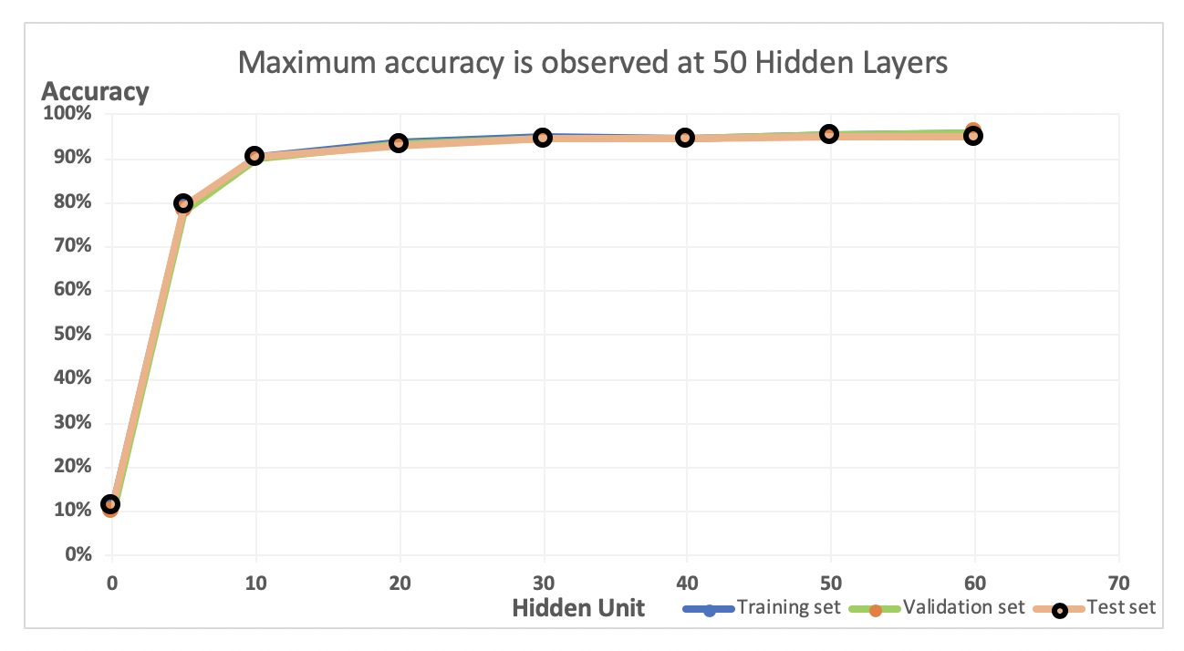Lambda value* is set to default = 0. Following values are obtained:

|  |  |  |  |
| --- | --- | --- | --- |
| Hidden Unit | Training Set Accuracy | Validation Set Accuracy | Test Set Accuracy |
| 0 | 11.48% | 10.00% | 11.35% |
| 5 | 78.93% | 78.11% | 79.29% |
| 10 | 90.48% | 90.10% | 90.32% |
| 20 | 93.66% | 93.38% | 93.13% |
| 30 | 94.80% | 94.75% | 94.50% |
| 40 | 94.76% | 94.40% | 94.51% |
| 50 | 95.50% | 95.27% | 95.13% |
| 60 | 95.78% | 95.88% | 94.89% |

Observations:

* With 50 hidden layers, we get the best Test Set Accuracy of 95.13%.
* With too many hidden layers we are facing the problem of overfitting and accuracy starts to drop when we increase the number to hidden layers to 60.
* With very few Hidden layers we can observe the problem of under fitting with a low accuracy of 79.29%.

|  |  |
| --- | --- |
| Hidden Unit | Time(In sec) |
| 0 | 2.0869 |
| 5 | 20.0605 |
| 10 | 24.131 |
| 20 | 37.552 |
| 30 | 34.044 |
| 40 | 34.068 |
| 50 | 36.632 |
| 60 | 41.973 |

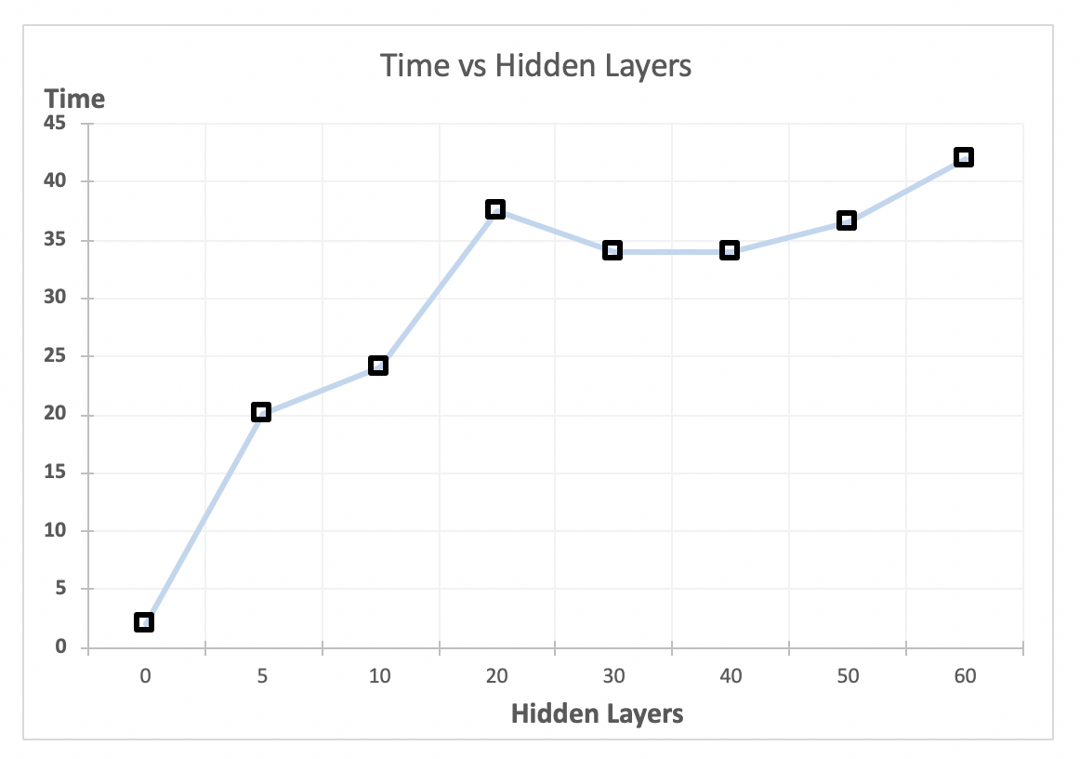

Conclusion:

It is evident form graph that with the increase in number of hidden layers the accuracy of Neural Network increases and the computation time increase as well.

But accuracy drops for a neural network with more than 50 nodes but the computation time continues to increase. Hence, we can conclude that with 50 hidden nodes our neural network works best on the MNIST data.

*Note: In the above computations, the value of λ was set to 0.*

**ERROR FUNCTION AND BACKPROPAGATION:**

Objective:

* Compute optimal Regularization Coefficient for Error function computation and Backpropagation.

|  |  |  |  |  |
| --- | --- | --- | --- | --- |
| Lambda | Hidden Unit | Training Set Accuracy | Validation Set Accuracy | Test Set Accuracy |
| 0 | 50 | 95.50% | 95.27% | 95.13% |
| 5 | 50 | 95.94% | 95.77% | 95.53% |
| 10 | 50 | 95.72% | 95.02% | 95.20% |
| 15 | 50 | 95.16% | 94.66% | 94.80% |
| 20 | 50 | 95.02% | 94.94% | 94.76% |
| 25 | 50 | 94.66% | 94.64% | 94.52% |
| 30 | 50 | 94.71% | 94.31% | 94.37% |
| 35 | 50 | 94.67% | 94.30% | 94.51% |
| 40 | 50 | 94.57% | 94.48% | 94.24% |
| 45 | 50 | 94.48% | 94.18% | 94.36% |
| 50 | 50 | 94.18% | 94.18% | 93.94% |

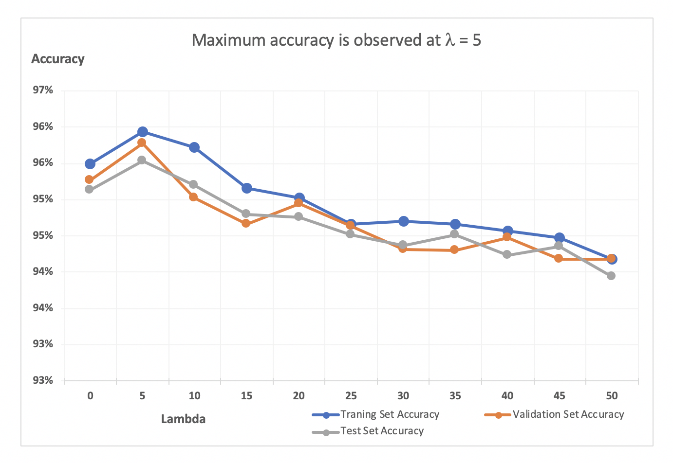Observations:

* The above graph shows the different Training, Validation and Test Set accuracy for different regularization parameters.
* We can observe that with increase in regularization parameter the accuracy increases and gradually drops from λ = 10.
* Non-Regularized (λ = 0) performs least efficiently as the algorithm was not able to converge at local minima, consequently making it harder for the system to learn weight.

|  |  |  |
| --- | --- | --- |
| Lambda | Hidden Unit | Time(In Sec) |
| 0 | 50 | 26.02205676 |
| 5 | 50 | 23.83797178 |
| 10 | 50 | 24.71857586 |
| 15 | 50 | 23.29902044 |
| 20 | 50 | 23.57502859 |
| 25 | 50 | 22.62298982 |
| 30 | 50 | 24.33622745 |
| 35 | 50 | 23.64994618 |
| 40 | 50 | 24.50004585 |
| 45 | 50 | 24.7822738 |
| 50 | 50 | 23.58422237 |

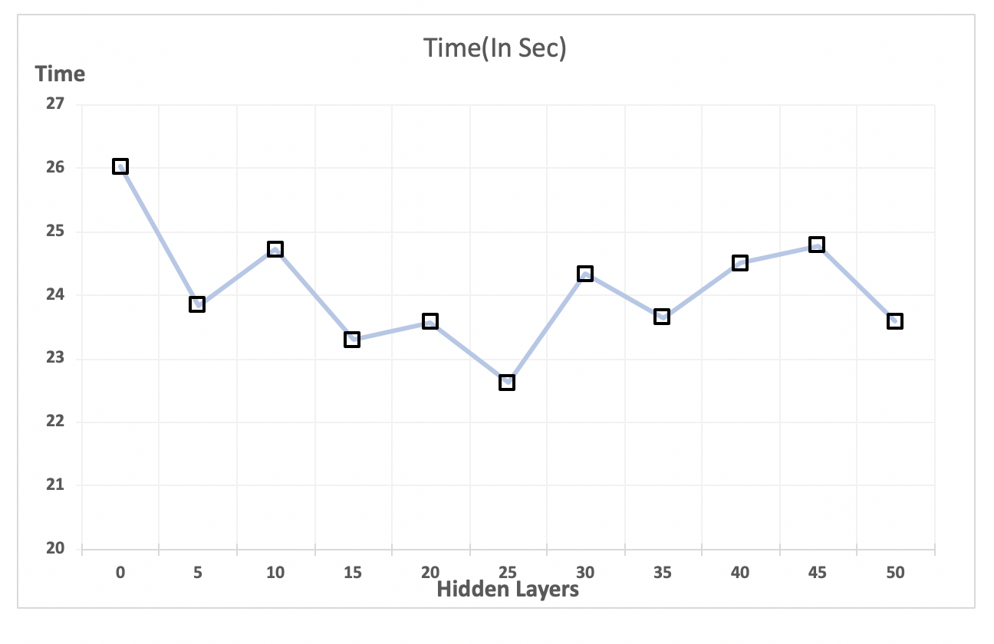

Conclusion:

With increase in regularization parameter, accuracy increases. But on further increase in value i.e. for λ > 10, accuracy starts to drop and error does not converge. Hence, we can conclude for backpropagation on multilayered neural network with 50 hidden nodes, works best with the regularization parameter of 5. It can also be observed that there is a removal of *124 features*.

**Problem 2**: Multi-Class Logistic Regression:

Objective:

* Compute the accuracy of CelebA data using facennScript using the regularization parameter obtained from nnScript. (*Neural Network*)

*Lambda and Hidden Unit values* are set to default. Following values are obtained:

|  |  |  |  |  |
| --- | --- | --- | --- | --- |
| Lambda | Hidden Unit | Training set Accuracy | Validation Set Accuracy | Test Set Accuracy |
| 10 | 256 | 85.02% | 84.20% | 85.39% |

*Lambda and Hidden Unit values* are set to the values obtained from the previous observation. Following values are obtained:

|  |  |  |  |  |
| --- | --- | --- | --- | --- |
| Lambda | Hidden Unit | Training set Accuracy | Validation Set Accuracy | Test Set Accuracy |
| 5 | 50 | 85.11% | 84.84% | 85.47% |

Objective:

* Compute the accuracy of CelebA data using the deepnnScript – Deep Neural Network

|  |  |  |
| --- | --- | --- |
| Hidden Layers | Accuracy | Completion Time (in seconds) |
| 3 | 81.642693 | 75.91169906 |
| 5 | 82.059044 | 72.29148412 |
| 7 | 80.772144 | 76.68332076 |

Conclusion:

* We conclude from the above observation that our Neural Network does a better job than the deep neural network as our task is not that complicated and adding more hidden layers merely leads to overfitting.

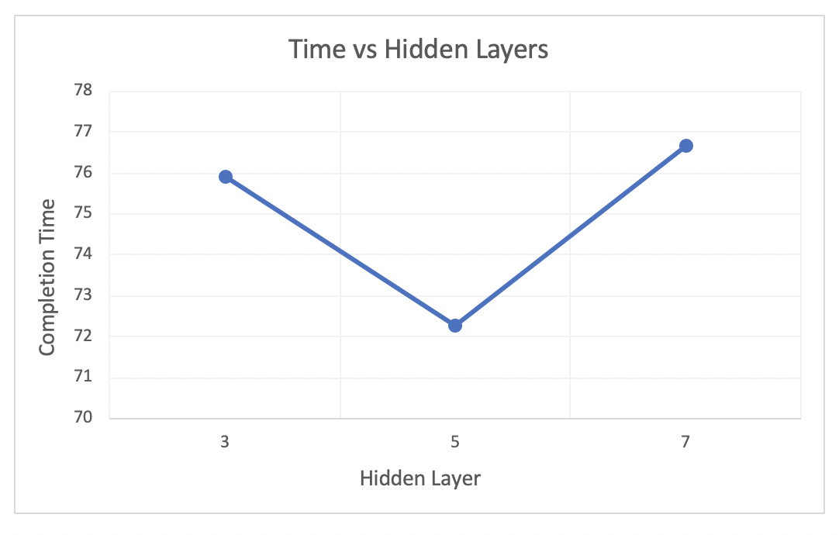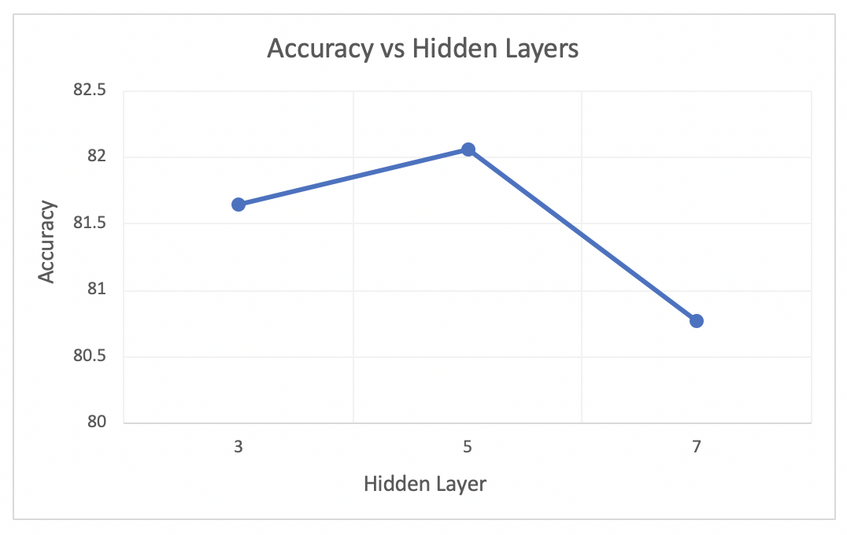

**Problem 3**: Support Vector Machines

Objective:

* Results from Convolutional Neural Network in terms of accuracy and time.

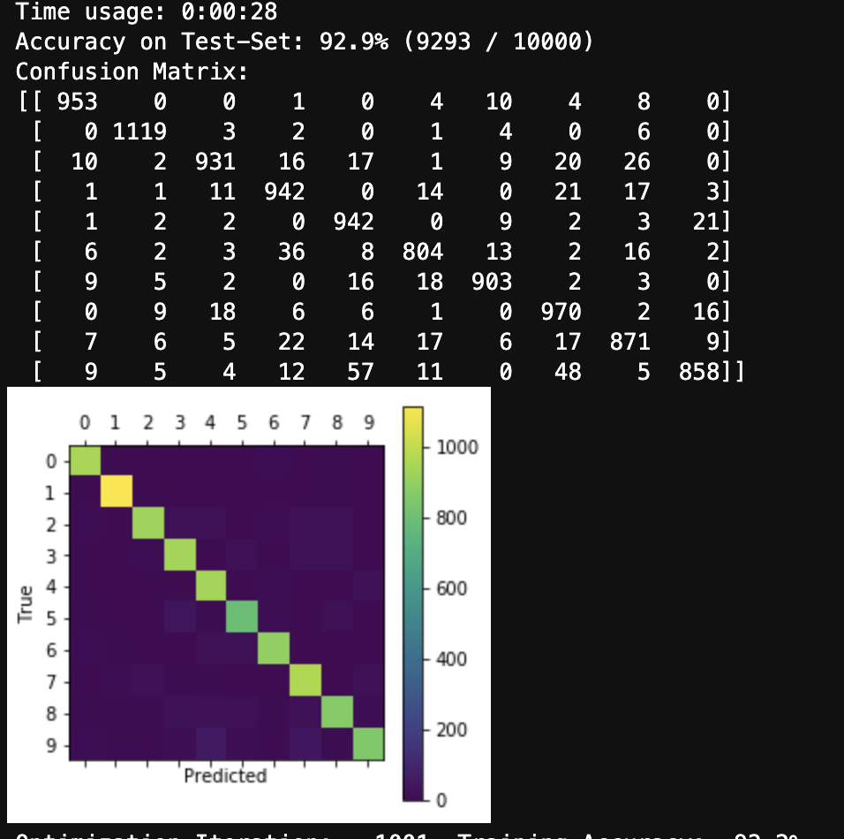Results:

Observations:

|  |  |
| --- | --- |
| Iterations | Test Accuracy |
| 1 | 8.30% |
| 100 | 58.50% |
| 1000 | 93.10% |
| 10000 | 98.70% |

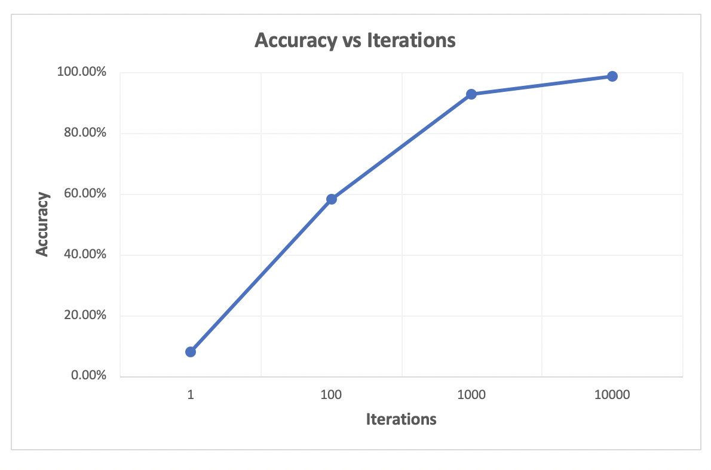

|  |  |
| --- | --- |
| Iterations | Time (in secs) |
| 1 | 0 |
| 100 | 3 |
| 1000 | 28 |
| 10000 | 285 |

